Project Assignment

Name
Institute of Affiliation
Professor
Date

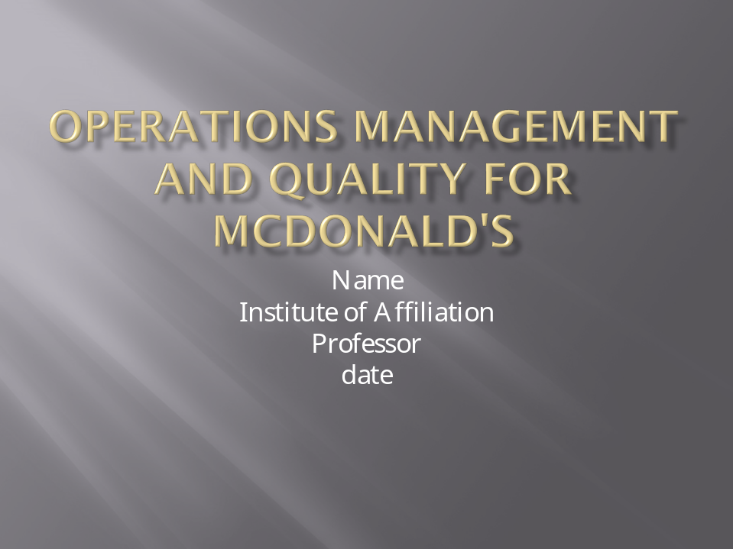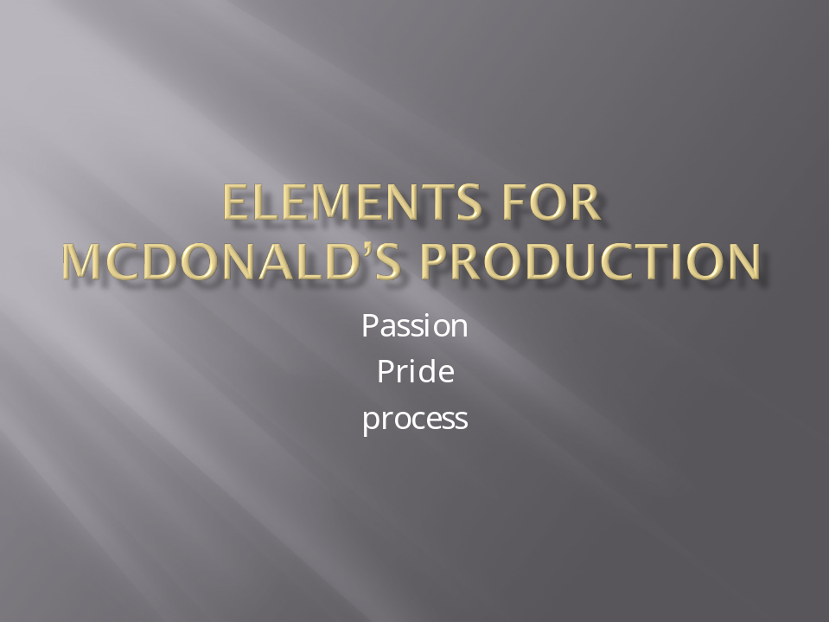
Production is the core element in McDonald’s which determines how their clients will respond to various products prepared during the production phase. McDonald’s puts a lot of passion for their products which is why it is the number one leading fast food business globally. The pride they have for their products is seen from cattle selection to the final fine burgers that have lower calorie content. Every process is vital as it is the reason why competition has failed to keep up with this food business for decades.


Over the years, McDonalds have maintained consistency in their tastes and customer choices. They continue to improve according to customer’s preferences over the years for example they have utilized social media for adverts which lures customers to purchase more. They have adopted new ways of spotting and growing talents in their facility where more young people are incorporated in the organization to give new ideas that have seemed to keep their customers satisfied. Learning how to work with people is another element that McDonald has utilized over the years since people are dynamic. They have greatly mastered the art of cross selling which has boosted their sales over the years plus those of the accompanying products for example juices or coke drink.


McDonald’s is committed to providing value for their customers where the clients get a product that is worth their money. Safety is another core element that the organization upholds either for their staff or their clients. This is ensured at their places of work and when making door to door deliveries for their clients. Without quality, McDonald’s would not be one of the biggest companies globally. This is seen by incorporating healthy choices for their clients while still maintaining quality for their fries and burgers. This is done by selecting the best fine products from the best suppliers to deliver quality products. Quality is accompanied by cleanliness an additional plus for McDonald’s in all their fast foods joints and their delivery systems.

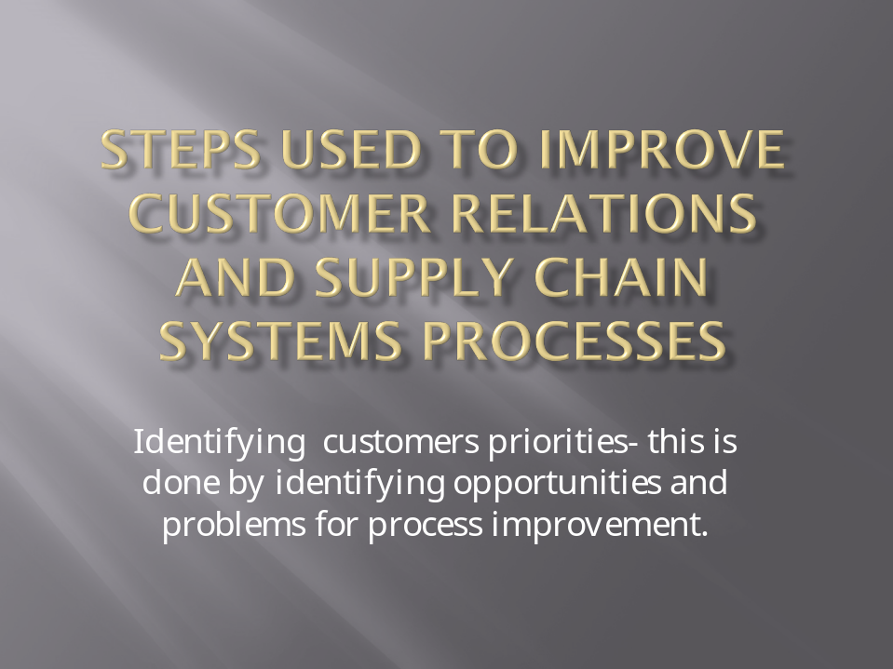
McDonald’s continues to be the leading company in the fast food business. It acts as a good example for other organizations by focusing on their clientele. This has been achieved by giving simple and easy experiences that create a return customer base while working under a slogan which entails low prices, fast service and precise orders.


In order to improve the waiting time, the staffs are supposed to inform their clients of the waiting time needed to prepare and deliver the product to avoid cancellation of orders. Waiting has resulted in refunds where the clients do not want to wait or the staff fails to mention the extra time needed to prepare different orders. This is why McDonald’s developed a pilot test to counter the amount of time the clients have to wait for their products which is also used as a marketing strategy for example “hot as you like it

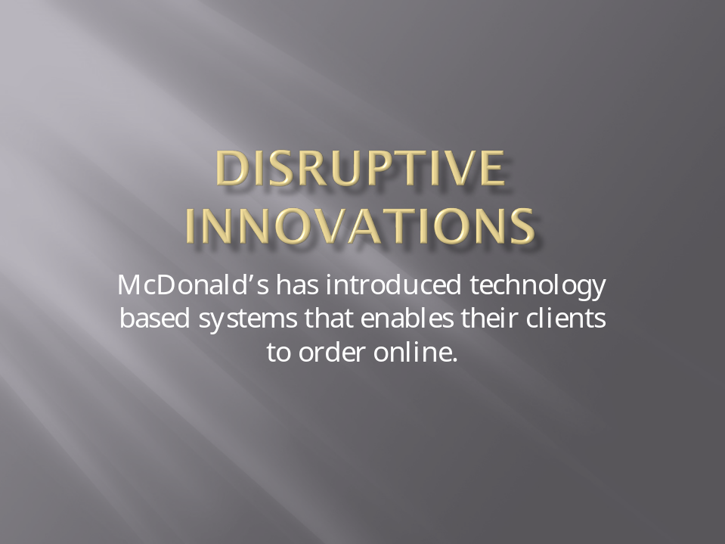
McDonald has adopted digital system that enables their clients to use digital platforms like mobile apps and online services that helps their clients order online at the comfort of their homes or the places of work. This has eased the congestion that has been building at some of the McDonald’s places that result in order cancelations and delays. By placing orders online, the customers have a wider variety of choices as they are provides with a menu that effectively satisfied their needs.

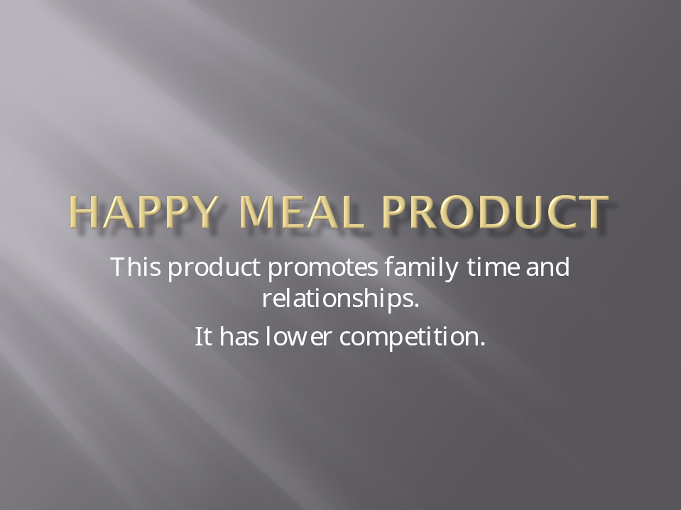
Happy meal product has over the years improved family relations where the children spend quality time with their parents while enjoying games that are accompanied by the product offering a family friendly environment. With an introduction of lower calorie contents, the happy meal product has remained relevant over competition from other brands like KFC.
The organization follows a top capacity strategy that enables the business to improve on production while increasing the demand for the product.

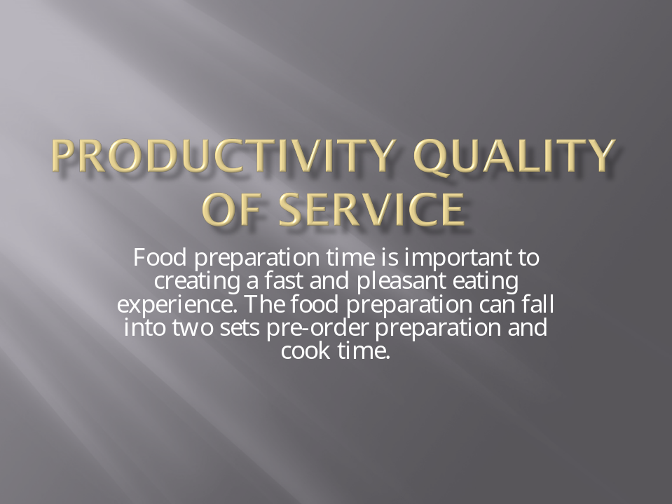
Food preparation time is important to creating a fast and pleasant eating experience. The food preparation can fall into two sets pre-order preparation and cook time.
Ordering time should be minimized while paying attention to the clients. The drive through time should involve ready foods to minimize on time compared to waiting inside time. These two methods should be well calculated to avoid cancellations and refunds.

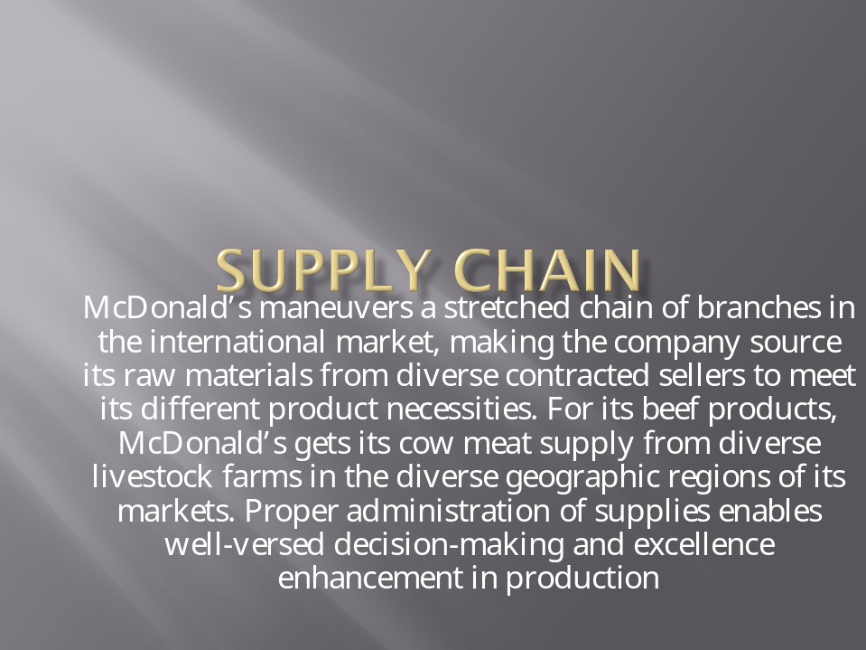
McDonald’s attaché documentation tags on the animals, which traces the cows to the place of source and processes. These tags ease the proper handling of the beef products in line with the reputable regulations. McDonald’s has implemented an electronic supply system, the E-procurement, which permits skilled users to trade their goods.

How would you define Quality, and how is Quality Measured in this Company or
Industry?
Quality can be defined as a standard of an item as dignified against other objects of a related kind. The clients expect a hygienic, quality, and quick delivery of food. McDonald’s is highly placed at a high-quality service for their clients with the least minimal time possible. There are a lot of processes and procedures that have been in place to ensure that they offer the best quality delivered at their client’s convenience. McDonald's has continued to hold a high position globally in quality by upholding the 4cs, culture, customer, communication, and collaboration to ensure their clients receive the highest quality products at their convenience.
McDonald's has continued to fulfill customers' tastes and preferences due to its commitment to customers' promises. This involves being open and direct about their restaurants, food, and culture. This is seen in most of the podcasts to assure parents how safe the food is for their children (Ceil, 2017). In terms of culture, McDonald's revolves around service, quality, value, and cleanliness. Part of the culture involves inspecting every store for safety, cleanliness, and daily standards. The same is expected of the suppliers who comply with the set standards like delivering good quality meat, and the results are shared with USDA. Communication and collaboration are other steps to ensure quality, which involves plant-level sensual programs, process control tracking, and data sharing. This goes to their suppliers, who are also expected to share their quality and safety practices.
What are Service or Production Activities not under total control? Identify the Service Activities that affect Quality for Customers that are controlled and those that cannot be controlled.
Some of the services that are not under control are some of the products preparation processes. McDonald's has been criticized for misleading advertisements, especially for children and teenagers influencing their purchase decisions. Although this can be controlled, the process of making fries cannot be controlled. Fries contain some of the largest calorie content, and although McDonald's is trying to incorporate some healthy choices, some of the products on the menu cannot be altered (Janssen et al., 2018). As a fast-food business, most of the products cannot be controlled, which is why the menu strictly indicates healthier choices and those that are not.
McDonald's services are geared to ensure the best service experience for their clients; however, this is not always the case. Sometimes preparation time for some products like McWraps takes longer than expected, leading to customer complaints. Other times, McDonald's has had to discontinue some products for operational purposes leading to disappointments on their clients as they get attached to the product. McDonald's copies upscaled burgers which turns catastrophic instead of sticking to their original easy and affordable burgers. Additionally, McDonald's lacks the creativity to improve on customer service compared to the competition. The competitions has quickly adopted precise ordering and secure payment options that favor their clients, unlike McDonald's, which is still operating through human-to-human interactions even after the pandemic. McDonald's has hiked their prices for small purchases like hamburgers, which can easily be purchased from local vendors (Janssen et al., 2018). These services can be controlled with proper strategies to avoid other effects on their quality while others cannot be controlled like the time needed to prepare the burgers and the fries, which still affect the quality at McDonald's.
How does the Company Resolve External Factors that Impact Quality? What methods or process Improvement Strategies might you consider Improving Service or Production Operations?
Some of the external factors that affect quality are cultural and political segments that require McDonald's products to adhere to health requirements. The company resolves these factors by providing extra selections on the menu that are healthier. This includes salads that can accompany the fries and burgers.
Some of the methods that can improve service operations are; customer delivery service that does not involve human-to-human contact to keep up with competition while combating the effects of the pandemic, keeping consistency on new selections to avoid losing loyal customers affect discontinuing some products like McWraps (Fredericks, 2019). Lastly, they should create menus that offer a variety of food rich in fiber to keep off competition.
McDonald's has continued to hold a high position globally in quality by upholding the 4cs, culture, customer, communication, and collaboration to ensure their clients receive the highest quality products. Some of the services that are not under control are some of the products preparation processes. McDonald's has been criticized for misleading advertisements, especially for children and teenagers influencing their purchase decisions. Although this can be controlled, the process of making fries cannot be controlled. Fried contains some of the largest calorie content, and although McDonald's is trying to incorporate some healthy choices, some of the products on the menu cannot be altered. With more competition, McDonald’s will continue to thrive if they uphold their quality guidelines and improve according to customer tastes and preferences in the new future.

References
Ceil, C. (2017). Service Quality and Branding Strategies at McDonalds. Available at SSRN 2984100.
Fredericks, G. (2019). Employment: What McDonald's can teach us about franchisor liability. LSJ: Law Society of NSW Journal, (61), 80-82.
Janssen, H. G., Davies, I. G., Richardson, L. D., & Stevenson, L. (2018). Determinants of takeaway and fast food consumption: a narrative review. Nutrition research reviews, 31(1), 16-34.
Srinivasan, M. (2017) Southwest Airlines Operations- A Strategic Perspective. Retrieved from http://airline-industry.malq.net/southwest-airlines-operations-a-strategic-perspective/

